3.RESULT

Screenshot of story

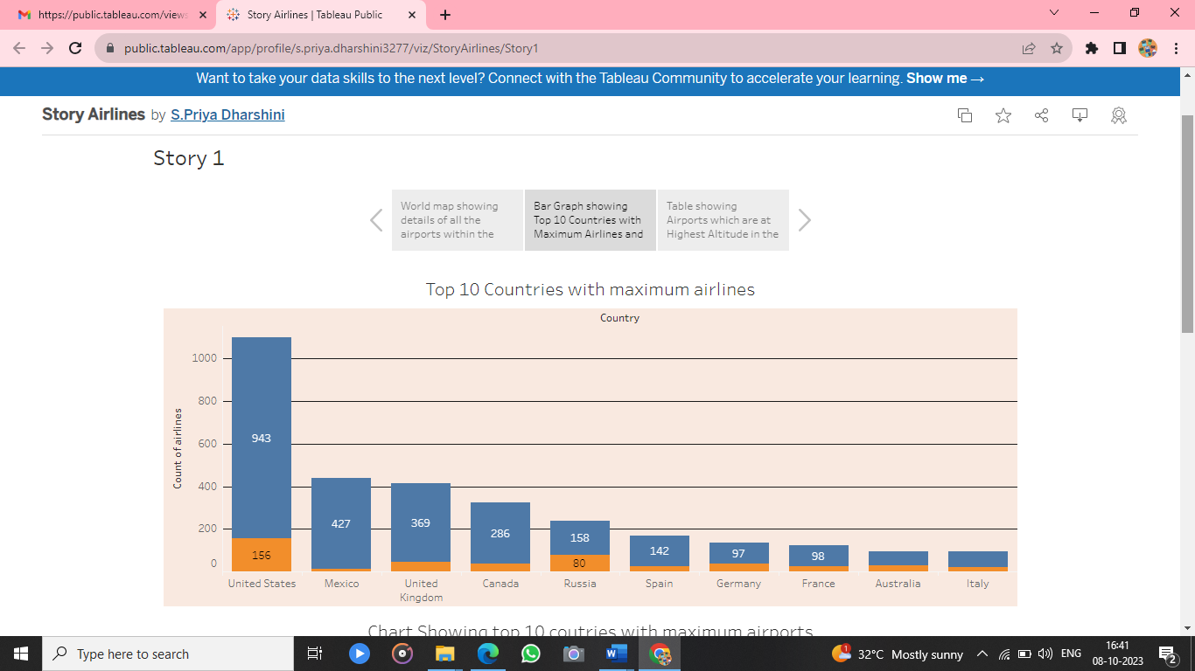

Screenshots of dashboard

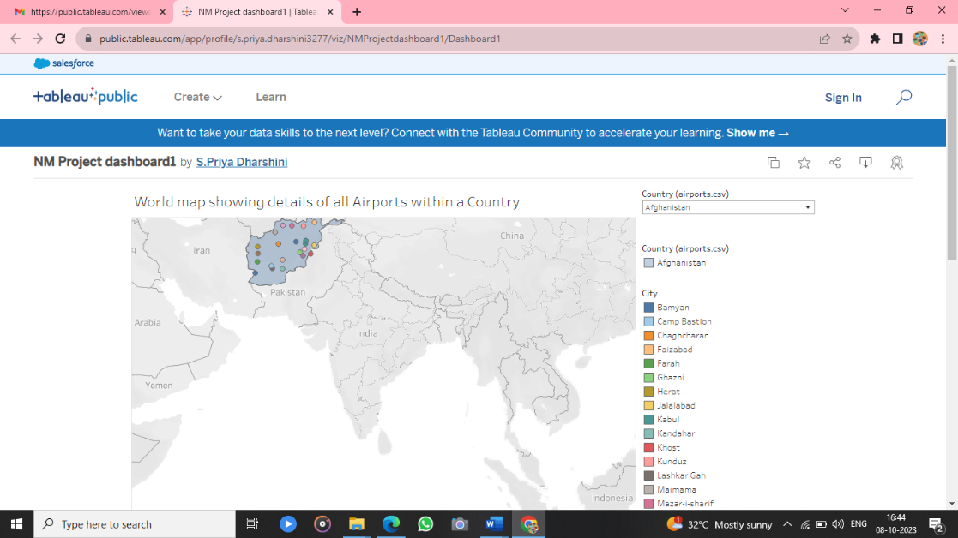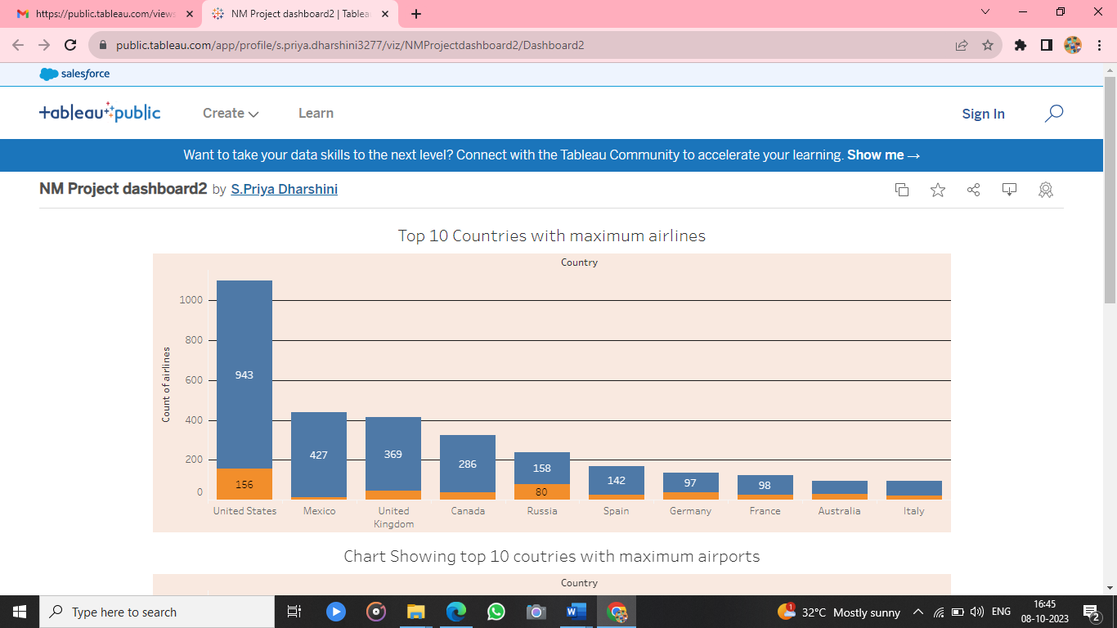

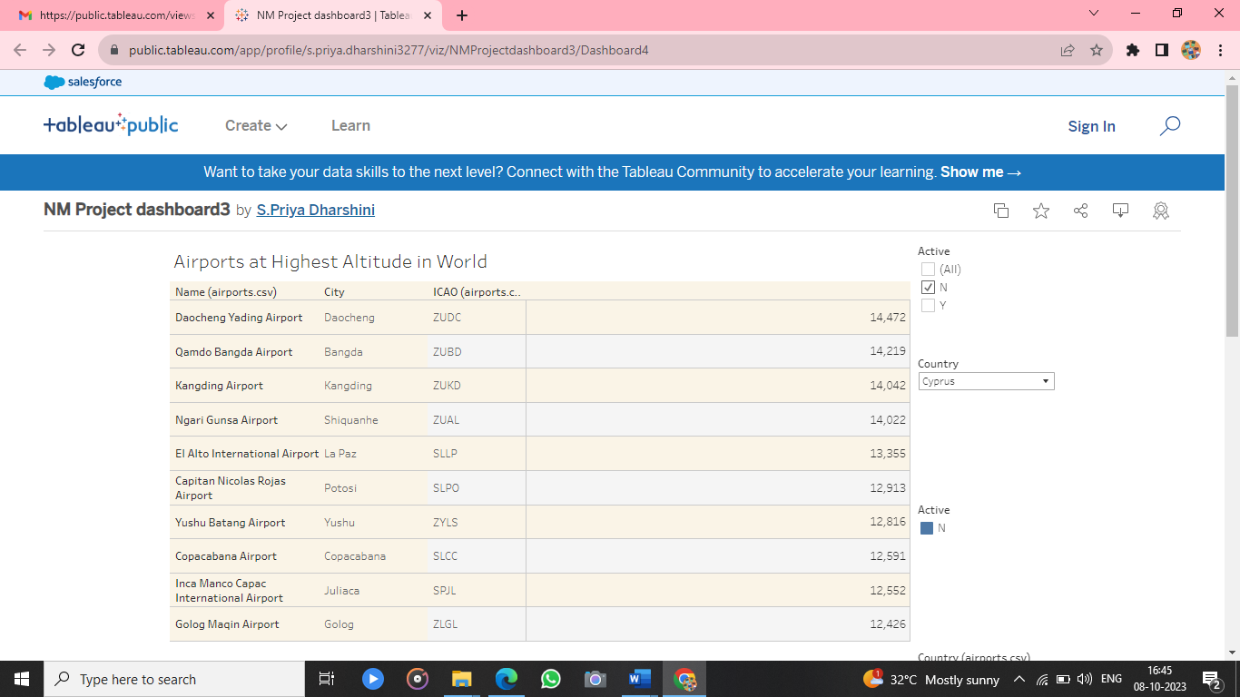

### 4.Advantages and Disadvantages of Air Transport

Here are some advantages of Air transport:

**Fast speed:**Air transport is capable of moving bulky cargo and hundreds of people very fast in any part of the world. Obviously, it is much faster than any mode of transportation like road transportation, rail transportation or water transportation.it is well used in nation emergencies due to its speed. In India, railways are majorly used by people for moving to any part of the country due to its economic service but nowadays people are moving towards airways for its fastest speed and people want to reach their destination as soon as possible .

**Rapid service:** Air transport is easy,  dependable and definitely the fastest way to transport passengers and goods. It offers rapid and convenient service at a low cost  . Air transport is the best way for the transport of ramble goods due to its fastest service.

**Low infrastructure:** Air transport travels totally on a natural path so it just requires very less investment for its maintenance. Apart from constructing airports from where air traffic is also controlled, there is no other infrastructure needed like making rail paths or several stations like in railways or in any other mode of transportation.

**No physical barriers:**As land routes have so many obstacles or barriers like divided regions need special permission every time which is not applicable while travelling by air.  There are no obstructions like mountains, rivers or any other element which can affect its speed.it works on a direct route and hence it is faster than other modes of transport.

**Defence service:**Every country is very much reliant on airforce service. Nowadays wars are not only fought on land borders but the air force offers a much easy and fast way to reach the enemy and vanish their evil intentions without much loss. During natural calamities like earthquakes, floods etc. it plays a very vital role in saving the lives of people and providing them special service in bad times.

**Security:**Air transport provides quick and comfortable service with a very secure environment for people to travel around in any part of the world where other modes cannot reach. Travelling with very delicate or high-value goods over long distances is convenient through air transport.

Disadvantages of Air Transport

Here are some of its disadvantages:

**Costly service:** As compared to land transport, rail transport and water transport this is relatively more costly for its services. Passengers cannot travel frequently if they are not financially good. Although Air service offers not only costly business class seats it provides economical class also which is cheaper than business class but still, it is costlier than other modes of transport.  It applies the same to cargo. Though it provides faster service than other modes which is great for trading air service goods are costly and need special permission.

**Limited capacity:**Air transport provides fast means of transportation but it has the drawback of the limited capacity of goods which is better in other modes. It is not good for bulky cargo and has limitations on the number of passengers travelling. Also, some kind of goods such as batteries, gases, fired solid and liquids etc.

**Undependable and risky:**Air transport travels in a natural path so it is totally dependent on the weather which makes it sometimes uncertain to travel in bad weather conditions such as fog, rain and snow etc. which causes cancellation of flights or diversion of its routes and makes it risky to travel.

**Accident-prone:**Compared to other modes air travel is always at high risk of accidents. There are more accidents on count while travelling by air transport. The reason can be bad weather, signal issues or machine parts failure which causes loss of people, crew or goods.

**Requires Skill:**There are trained people required to fly an aircraft and because of it air travel becomes a little costly due to limited crew.

**Unfit for cheap and bulky goods:**Since airways are costly due to numerous conditions, it becomes expensive to move cheap goods and also aircraft are small in size as compared to other modes so it’s difficult to load bulky cargo.

### 5.APPLICATION

Using the data analytics, which was built with the help of tableau desktop we can make several solutions .A data analyst can give the solution to any of the problem that a specific company have in their business.

Through this we can achieve in the improvement of the company with the understanding of the people’s likes on their business.So it makes increase in their profit .

We can able to understand the density of the airports within a country from the world map that we have made in tableau.

Also for the accurate number of airports we can refer the dashboard 3.Which gives us an idea of the airports within a country.The number of flights that take off from each airports can be conveyed through the bar graph.This can be applied to improve the airports that are severly to be concerned to increase their numbers in certain regions.

From the reports that have been made from the tableau we can understand which airport is placed in highest altitude in the world as well as in the country.

It also depicts where all the airports are active and inactive within a country . This can be come into the knowledge of the airlines to make it active or to make the land to use in a proper way of the inactive airports in these countries.

### 6.CONCLUSION

Through the data analytics we have learnt to find the solutions for a question. This tableau desktop helps us in making various visualisation with its features that have been provided in a user-friendly manner. These visualisations involves bar graph , pie chart, donut chart and so on.

These visualisations helps a common man to understand what we are able to convey to them.

The measures are very convenient for us to make the visualisations so easy. The airlines , airports, its routes all have a different strategies to maintain for the public usage.

We are able to understand those countries with maximum airlines are where the people mostly prefer the airlines for their travel.

These countries are the developed countries that are well maintaining their airlines and the airports properly.

### 7. FUTURE SCOPE

We must come to an conlusion of those airports that are inactive in each countries . And must take the necessary actions for those inactive .

To connect the globe we must look into those countries with minimum airports and take the necessary steps to make people afford the aircrafts.

This would make the use of airplanes more efficient for the people and reduces the time that consume when we travel via other forms of transports.

Improving flight paths is necessary. Receiving real-time data about weather patterns allows airlines to optimize flight schedules and fuel efficiency.

With this information, airlines can redirect flights to enhance efficiency.